**Annex D. PROJECT LOCATION/SITE PLAN**

**General site description**

* The project will be implemented at the existing Dire Dawa dump site.
* 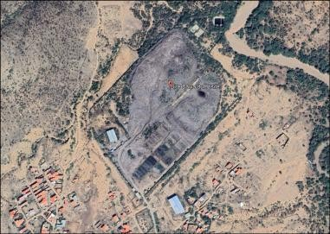The site is situated at **Latitude 9.634384° North and Longitude 41.882355° East**, within the administrative boundaries of **Dire Dawa, Ethiopia**.