As Simiya (As Samu’)

Hebron

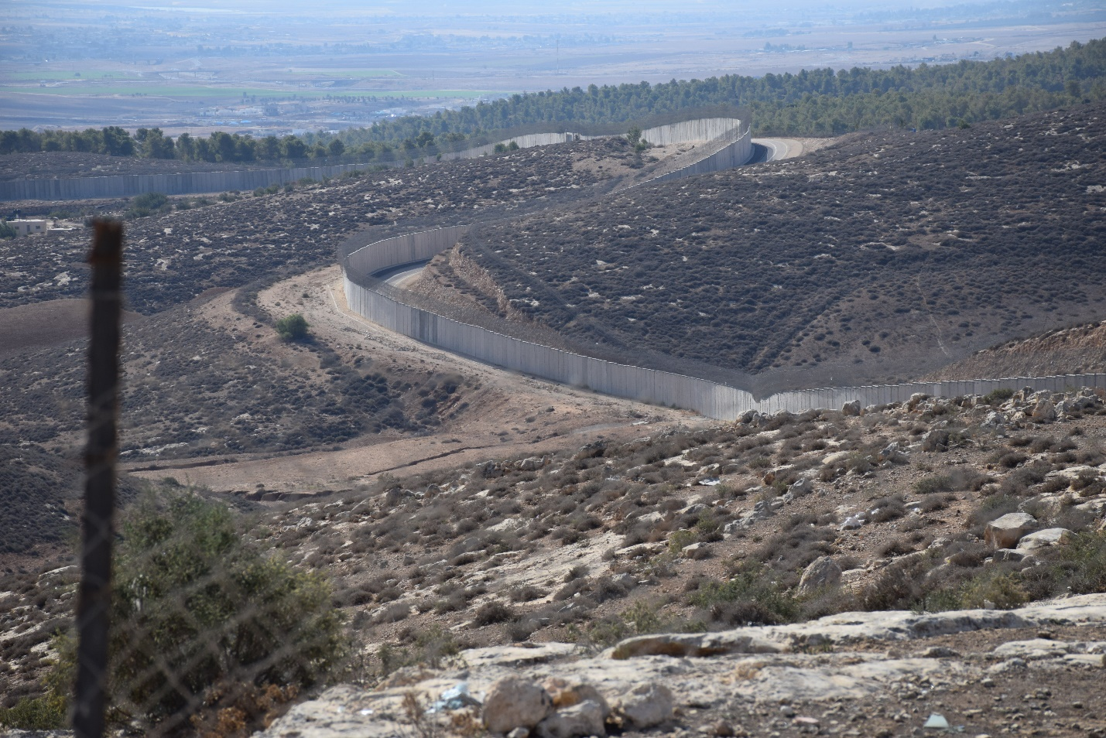

September 2020

## **Location and boundaries**

As Simiya is located within As Samu’, which is located south west of the city of Yatta, in the South Western part of the Hebron Governorate, 18 km from Hebron city. It is bordered by Dura and Yatta from the north and east, Dhahriyah from the west, and the separation barrier from the south. According to the municipality[1], historically the land of Samu’ consists of 138,000 dunums, but after Israeli confiscations only 35,000 dunums remain.

## **Etymology**

As Simiya is named for its ancient water well from the time of the Romans with a depth of more than 15 meters and made from ancient stone that has indentations where the ropes pulled the water. While the origin of the name As Samu’ comes from the Canaanite period and means obedience.

## **Population**

According to population projections based on the Population, Housing and Establishments Census 2017, prepared by the Palestinian Central Bureau of Statistics (PCBS) the population of As Samu’ reaches 32,337, of whom around 49.3% are females, As Simiya has around 1,112 inhabitants, 504 males and 497 females[2]. According to PCBS 26.2% of the population (or 6,766 people out of 25,785 of the 2017 population) are poor.

## **Topography**

As Samu’ is 705 meters above sea level and slopes towards the south west, according to PCBS (2017) it has 5,510 structures, 241 of which are in the As Simiya area[3].

## **The Area**

The area of As Simiya to be surveyed and registered within this project is 12,043.20 dunums, 63 per cent of which is located in Area C. The area also includes 919.8 dunums of high and medium agricultural value.

A local outline is being prepared for As Simiya including 1,017.3 dunums

## **Land and basins**

As Simiya is divided into many basins, some of which are: Ras Wadi Al Alali, Sha’b Al Ajouz Al Janoubi, Khallet Al Baraka, Wadi Hakko Ashamali, Khallet Assabbar Ajanoubieh, Sahl Al Jamamah Asharqiyya, Sahl Al Jamamah Algharbiyya, Khirbet As Simiya, Wadi Hakko Ajanoubieh, Ras Shaab Al Butm, Shaab AlButm, Khallet Abu Salem, Shaab Al Ajouz Ashamali, Marah Al Rabya, Al Rumaitha, Al Rabya, Shaab Al Arab, Khallet Al Karasna Asharqi, Maktal Musallam Asharqi, Khallat Al Jahsh, Al Jawfat Algharbiyya, Al Jawfat Asharqiyya, Maktal Musallam Algharbi, Jouret Hariza Ajanoubieh, Jouret Hariza Algharbiyya, Shaab Al Tareq, Beer Ghannam, Jouret Hariza Asharqiyya, Al Qatfa Al Tahta, Al Jawfat, Shaab Abu Zarka, Wad Al Alali Algharbiyya, Wad Al Alali Asharqi, Ras Wad Al Alali Asharqi, Khallet Al Mafateeh, Marah Shaab Al Butm, Khallet Al Karsana Ashamali, Shaab As Sahara, Khallet As Sabbar Asharqiyya, Mughayan As Simiya, Sha'aba Al Rabya, Ras Wadi Al Qatfa.

## **Local authority**

As Samu’ municipality has 13 members, including two women. The head of the municipality is Mr. Hatem Al-Mahareeq.

## **Surrounding Israeli Settlements[4]**

## As Samu’ is surrounded by Israeli settlements, Otniel settlement to the north with around 1,000 settlers, Mitzpe Eshtamoa and Shim’a settlements are to the west and built on its land (around 40 and 740 settlers), Meitarim (Industrial Zone) settlement to the south-west and Asael settlement (17 settlers) to the north east, in addition to the 1,110 dunums confiscated for the construction of the separation barrier.

## **Families**

As Simiya’s families are Al Hawamdeh, Al Daghameen, Al Awawdeh. Al Mahareeq, Al Rawashdeh, Al Salameen, Al Zaareer, Al Khalyleh, Al Badareen, Abu Tbeikh, Abu Al Kabbash, Abu Karsh, Abu Seif, Abu Hammad, Abu Arqoub, Abu Ubeid, Abu Al Thom, Al Uqeili, Abu Eisheh, Abu Khalaf, Abu Uqeil and Salameen.

**Sources of income**

In As Samu’, 30 per cent work in Israel, while 20 per cent work in agriculture and raising livestock and 20 per cent in the service sector, followed by 15 per cent employed in public sector and 15 per cent in trade[5].

**Institutions and associations**

As Samu’ has three women’s organisations (one of which is in As Simiya) and no youth organisations.

## **Targeted area (map)**



1. As Samu’ Municipality Development Plan 2018- 2021
2. As Simiya Local Outline Plan, International Peace and Cooperation, 2015
3. As Simiya Local Outline Plan, International Peace and Cooperation, 2015
4. OCHA <https://www.ochaopt.org/atlas2019/isrsettlements.html>
5. (Arij, 2009) <http://vprofile.arij.org/hebron/pdfs/Ar%20Ramadin%20Village-en.pdf>