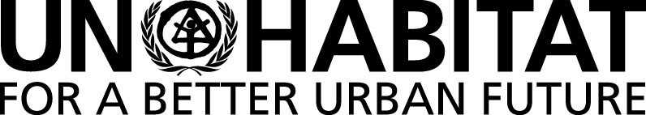 |  | United Nations Human Settlements Programme
 |  | P.O. Box 30030, Nairobi 00100, KENYA
 |  | Tel: +254-20 7623216
 |  | UN-HabitatGCSecretariat@unhabitat.org

60th MEETING OF THE SUBCOMMITTEE ON POLICY AND PROGRAMME OF WORK OF THE COMMITTEE OF PERMANENT REPRESENTATIVES (CPR).

World Urban Forum including preparations for the ninth session of the World Urban Forum (WUF 9). Additionally status of Implementation of the New Urban Agenda (NUA) and the draft Stakeholder Engagement Policy

Wednesday 13 December 2017 at 9:30 A.M.

Conference Room 4

Provisional Agenda

1. Adoption of the Provisional Agenda.
2. Presentation and Discussion on the World Urban Forum.
3. Briefing on the Status of Implementation of the New Urban Agenda.
4. Briefing on the draft Stakeholder Engagement Policy.
5. Any other matters.

