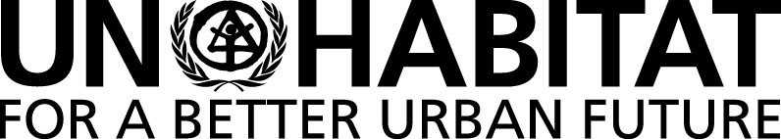 |  | United Nations Human Settlements Programme
 |  | P.O. Box 30030, Nairobi 00100, KENYA
 |  | Tel: +254-20 7623216
 |  | UN-HabitatGCSecretariat@unhabitat.org

SIXTH MEETING OF THE SUBCOMMITTEE ON POLICY AND PROGRAMME OF WORK OF THE CPR ON DRAFT RESOLUTION ON THE WORKING GROUP ON WORK PROGRAMME AND BUDGET

Wednesday, 28 March 2018 at 9:30 A.M.

Conference Room 4

Provisional Agenda

- Adoption of the Agenda.
- Update on the preparations of the Quadrennial Report on the implementation of the New Urban Agenda – Draft Annotated Outline
- Any Other Matters.

