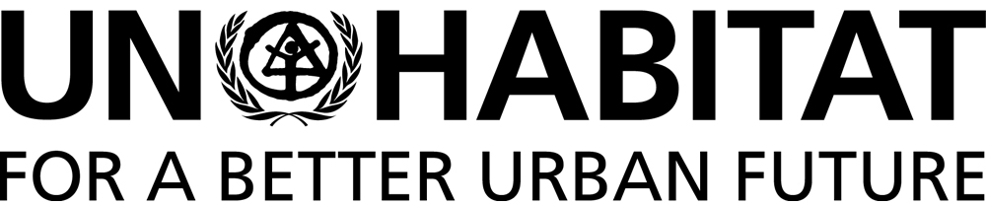

61ST REGULAR MEETING OF THE COMMITTEE OF PERMANENT REPRESENTATIVES TO UNITED NATIONS HUMAN SETTLEMENTS PROGRAMME
15 JUNE 2016

Item 6: Briefing to the CPR on the implementation Plan for Agenda 2030

HSP/CPR/61/6

Introductory Statement by the Executive Director

Distinguished Delegates,

We have shared with you a ‘Briefing note to the CPR on the implementation Plan for Agenda 2030’ elaborates on UN-Habitat’s engagement in the emerging monitoring and implementation dimensions of the 2030 Agenda. I will now present the key points of this note.

In September 2015, the United Nations Sustainable Development Summit adopted the 2030 Agenda, which contains 17 Sustainable Development Goals and 169 targets. The SDGs address, in an integrated manner, the social, economic and environmental dimensions of development as well as means of implementation. The goals and targets are expected to stimulate action over the next 15 years.

The General Assembly is debating a resolution on the ‘Follow-up and review of the 2030 Agenda for Sustainable Development at the Global Level’. This resolution will specify the themes and the sets of goals to be reviewed in depth during the current cycle of the high-level political forum under the auspices of the Economic and Social Council. The Economic and Social Council decided that the theme for the high-level political forum in 2016 is ‘Leaving no one behind’.

In March 2016, the Inter-Agency Expert Group (IAEG) on SDG indicators presented to the 47th Session of the Statistical Commission a proposal of a global indicators framework with 240 indicators. The Statistical Commission agreed with this framework as a starting point for global monitoring and requested the IAEG to refine indicators, recognizing that the development of a robust and high-quality indicator framework is a technical process that will need to continue over time.

The 2030 Agenda for Sustainable Development gives a prominent role to urbanization and cities with the inclusion of a stand-alone goal for cities and human settlements. The global indicator framework comprises 15 indicators for the 10 approved Targets of Goal 11.

The IAEG has designated ‘custodian’ agencies for each indicator. UN-Habitat has been designated as custodian agency for 8 indicators and as a supporting agency for another 5 indicators for Goal 11. The Agency was also designated as custodian agency for indicator on security of tenure along with the World Bank.

In close collaboration with various UN agencies, UN-Habitat prepared a Global Monitoring Tool for Goal 11 that provides definitions and metadata for all approved indicators for Goal 11. This tool will assist countries and cities in the definition of national targets and in their reporting and monitoring efforts. Working with various partners, UN-Habitat is refining approaches for the data collection, analysis and compilation of information for the urban SDGs indicators, particularly those with a spatial component.

UN-Habitat is proposing to local authorities and national governments the adoption of the City Prosperity Initiative (CPI) as a global monitoring platform for Goal 11 indicators and other SDGs with an urban component.

A new webpage on the role of UN-Habitat in the implementation, monitoring and reporting of the SDGs, in particular Goal 11, is currently being designed and constructed. The UN-Habitat website on SDGs will present information on relevant SDGs and showcase the significant role of the agency in implementation, monitoring and reporting.

UN-Habitat, along with UNDP and the Global Task Force of Local and Regional Governments for Post 2015 and Habitat III carried out UNDG-mandated Dialogues on Localizing the Post-2015 Agenda. The partners are currently elaborating a Toolbox for localizing the SDGs.

A framework for monitoring SGD 6 on Water and Sanitation was developed by UN-Habitat, WHO and UNEP, with key support from Switzerland. The initiative’s focus is to integrate and expand existing monitoring efforts on: wastewater treatment and water quality; water use and use-efficiency; integrated water resources management; and water-related ecosystems.

UN-Habitat in cooperation with ECLAC-Economic Commission for Latin America are working on strengthening accountability systems in Latin American cities for achieving the SDGs in cities and urban agglomerations, in particular Goal 11. This project has been approved for financing by the UN Development Account and it involves 9 cities in Bolivia, Brazil and Peru.

UN-Habitat offers national governments the possibility to assist them in the creation of a National Sample of Cities to ensure uniformity in reporting and better connection to national policies, using the same set of cities over time.

UN-Habitat is also working with partners to support and advocate for data generation for local governments in order to strengthen monitoring and measurement, including indicators on municipal finance.

All UN-Habitat branches and regional offices are reviewing their strategies to ensure alignment with the 2030 Agenda. The UN-Habitat Project Advisory Group (PAG) ensures that all new UN-Habitat projects and initiatives are being designed with the view to maximize congruence with the 2030 Agenda including SDG-11. Last week, the PAG approved two concept notes for projects aiming at supporting the implementation of SDG 11.1 (slum upgrading) and SDG 11.7 (public space) with a total value of USD 22m over 4 years.

These actions constitute our initial steps of engagement in the implementation and monitoring of Agenda 2030, while the institutional roles, indicator system and follow-up and review mechanisms are being finalized.

Thank you for your attention.

