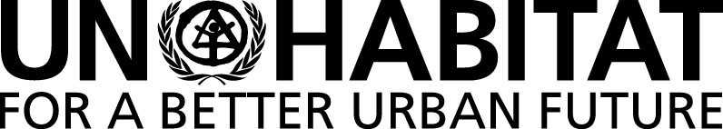 |  | United Nations Human Settlements Programme
 |  | P.O. Box 30030, Nairobi 00100, KENYA
 |  | Tel: +254-20 7623216
 |  | UN-HabitatGCSecretariat@unhabitat.org

56th MEETING OF THE SUBCOMMITTEE ON POLICY AND PROGRAMME OF WORK OF THE COMMITTEE OF PERMANENT REPRESENTATIVES (CPR).
UN-HABITAT’S WORK ON BEST PRACTICES INCLUDING THE DUBAI INTERNATIONAL AWARDS

Wednesday 25 October 2017 at 9:30 A.M.

Conference Room 4

Provisional Agenda

- Adoption of the provisional Agenda.
- Presentation and Discussion on Best Practices including the Dubai International Awards.
- Any other matters.

